


Equality and Engagement Impact Assessment

Please refer to the Guidance for Completion of the Equality and Engagement Impact Assessment. If you require any assistance in completing this form please contact the Patient Engagement and Experience team.

Title of service, policy or programme: | Fit for the Future 2
Name and job title involved in the completion of this assessment: | Becky Parish, Associate Director, Engagement and Experience, NHS Gloucesteshire Clincal Commissioning Group (Integrated Care Board from 1.6.2022)
Date of this assessment:  (It is good practice to undertake an assessment at each stage of the project) | 4 May 2022
Stage of service, policy or programme change  (earlier versions of this impact assessment should be included in your submission) | Development ☐ | Implementation ☐ | Evaluation/review ☐

1. Outline
Give a brief summary of your policy, service or programme. Include reference to the following:  - Is this a new or existing policy, service or programme?  - If it is not new, detail any proposals for change. | Fit for the Future is part of the One Gloucestershire vision focusing on the  medium to long term future of some of our health services.  At this engagement stage there are no proposals for change.  Duting the engagement period we plan to involve local people and communities in exploring ideas for how several services could develop in the future as part of FFTF2.  This time the conversation about some of these services is broader, covering both:  the continued development of the ‘Centres of Excellence’ approach at CGH and GRH, including inpatient care (where you need to stay in hospital for a while, including overnight)  and  Support for people in their own home, in their GP surgery or in the community.  The areas we want to focus on now are:  - Benign (non-cancerous) Gynaecology  - Diabetes and Endocrinology  - Frailty/Care of the Elderly  - Non-interventional Cardiology  - Respiratory  - Stroke
What aims/outcomes do you want to achieve? | Fit for the Future 2 engagement – conversations will focus on the following three areas:  How we can provide the very best care for people at each stage of their illness or  injury.  This includes:  - very specialist care for people when they are very unwell  - helping people to leave hospital at the right time - reducing delays and benefitting their recovery  - rehabilitation support for people to help them recover and regain their independence after an operation or other treatment and, in many cases, follow up care and support over the  - longer term.  Opportunities to join up care - improving communication and making care simpler and smoother across services and communities.  This could be between:  - related services in a hospital  - GP surgeries and community or hospital services health and social care services and;  - the NHS, social care and other key community partners such as local councils, voluntary and community groups and others.  - How we reduce health inequalities - ensuring that we improve health outcomes for everyone, regardless of where they live in the county and their social, environmental or economic circumstances.  How we reduce health inequalities  Ensuring that we improve health outcomes for everyone, regardless of where they live in the county and their social, environmental or economic circumstances.
Give details of any evidence, data or research used to support your work. Consider the following:
- Health Needs Assessment
- JSNA/Inform data
- National/regional data
- Patient experience data

2. Engagement
What relevant patient experience data/feedback is already available?  Include information from any relevant national/regional patient groups, eg. Healthwatch, national surveys | There is a significant amount of relevant insight data from the previous Fit for the Future Engagement and Consultation (2019-2021).This can be found on the Get Involved in Gloucestershire Platform: https://getinvolved.glos.nhs.uk/fit-for-the-future This includs the output of engagement and consultation reports produced by NHS Gloucestershire Clinical Commissioning Group, as well as independently produced Citizens’ Juries’ Report from 2020 and 2021.
How have patients, carers and families, staff been involved in shaping your proposals.  If your policy/programme is currently being developed, please explain any further plans for engagement and/or consultation.  (*Plans for additional engagement should also be included in the Section 5: Action Plan below) | This is an engagement, we do not have firm proposals. We will be asking people and communities to tell us what they think about our ideas for each of the services above.  As stated above, the Fit for the Future 2 Engagement has been preceeded by several years of conversations with the people of Gloucestershire, the staff providing services and key local stakeholders.
If your plans/policies are implemented please explain:
Any impact on the way in which services are delivered?  eg. change in location, frequency of appointments. | Four of the five services included in this engagement are already subject to temporary changes made in response to the Covid-19 pandemic. Most temporary changes have been in place for more than 12 months. The temporary changes related to change of location with services either provided from Cheltenham General or Gloucestershire Royal Hospital. No changes in relation to outpatient services at the two acute hospitals not the community hospitals in the county.
Any impact on the range of health services available? | The range of services is the same.
Have you considered whether any change could be considered significant variation? If yes, formal public consultation may be required (See Guidance or ask your Engagement Team for advice). | Full IIAs for each service have been undertaken. In summary the impact assessment for services consolidating on either the CGH or GRH site is often similar.  See Appendix 1 for details.

3. Equality considerations
This is the core of the Equality Impact Analysis; what information do you have considering any potential or existing impact on protected groups, as defined by the Equality Act 2010. Consideration should also be given regarding wider inequalities that people may experience because of social, domestic, environmental and economic circumstances, eg. unpaid carers, rural isolation, areas of deprivation. If your proposals contain more than one solution for service delivery, you should consider the potential impact for each of the solution in this section.

(Please complete  each area) | What key impact have you identified at this stage? |  |  | Explain any positive or negative impact below. What action, if any, has been taken to address these issues? | Further action required?  (*Include details in Section 5: Action Plan below)
(Please complete  each area) | Positive  Impact | Neutral  impact | Negative  Impact
Age | ☐ | ☐ | ☐
Disability | ☐ | ☐ | ☐
Gender reassignment | ☐ | ☐ | ☐
Marriage and civil partnership | ☐ | ☐ | ☐
Pregnancy and maternity | ☐ | ☐ | ☐
Race | ☐ | ☐ | ☐
Religion or belief | ☐ | ☐ | ☐
Sex | ☐ | ☐ | ☐
Sexual orientation | ☐ | ☐ | ☐
Other considerations | ☐ | ☐ | ☐
Other considerations: please consider, and identify, those who face health inequalities e.g. areas of deprivation, people with poor mental health, social/rural isolation, people who misuse drugs and/or alcohol, etc

4. Monitoring and review
If you are at the implementation or evaluation stage of your policy development/service or programme change:
Has an earlier Impact Assessment been undertaken? | Yes ☐ | No ☐ | N/A ☐
If yes, please include details of any action plan below:
What issues/actions have previously been identified?

Are any further actions required?

5. Action Plan
Issues/impact identified in Section 2, 3 or 4 above | Explain any further actions required | How will you measure and report impact/progress | Timescale for completion
When will the proposal be next reviewed?

5. Completion: | Name and Job title | Date
Completed by: | Becky Parish, Associated Director, Engagement and Experience | 4 May, 2022
Equality Lead: | Caroline Smith, Senior Manager Engagement and Inclusion | 4 May, 2022
Project Sponsor: | Micky Giffith, FFTF Director | 5 May, 2022
Policy/programme signed off by:  (eg. Governance and Quality, Governing Body, etc) | Marion Andrews-Evans, Director of Nursing and Quality | 6 May, 2022

Appendix 1
A full EIA for each service is provided in the relevant appendices (11a-11e), which includes all data and evidence-based review. The impacts for each EIA domain are presented below; the key indicates the nature of the impact. This key is used throughout this section.

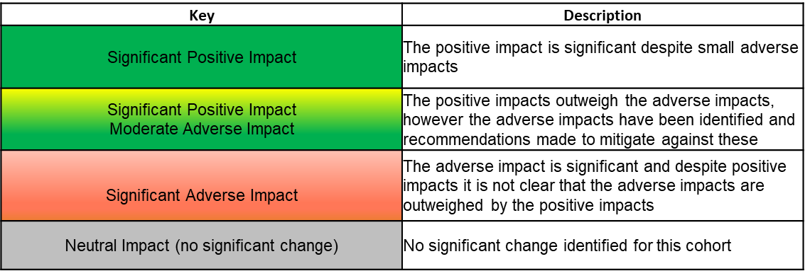

Equality Impact Assessment – Summary of Impact by Service Proposal

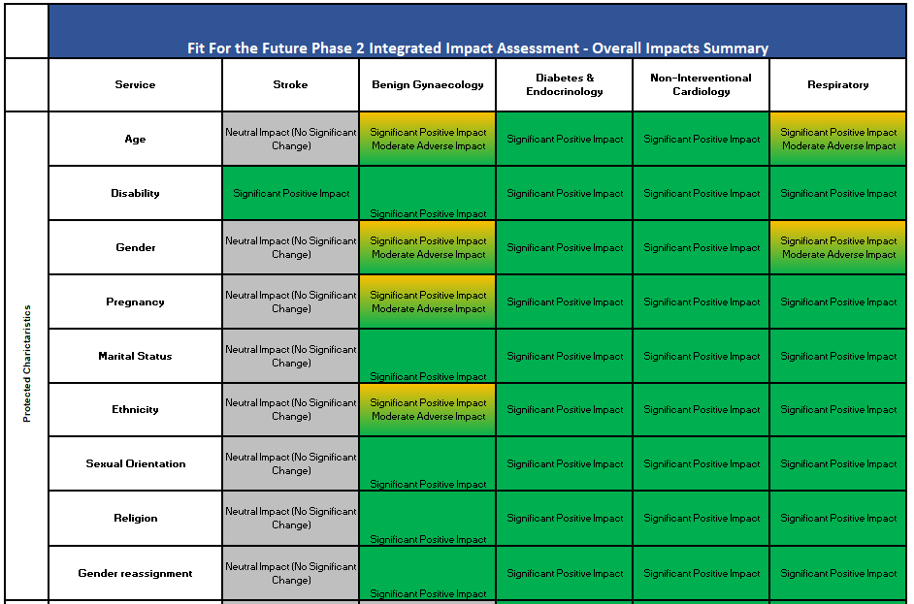

A full Health Inequalities Impact Assessment (HIIA) for each service is provided in the relevant appendices, which includes all data and evidence-based review. The impacts for each HIIA domain are presented below; the key indicates the nature of the impact; see key description used above.
Health Inequalities Impact Assessment – Summary of Impact by Service Proposal

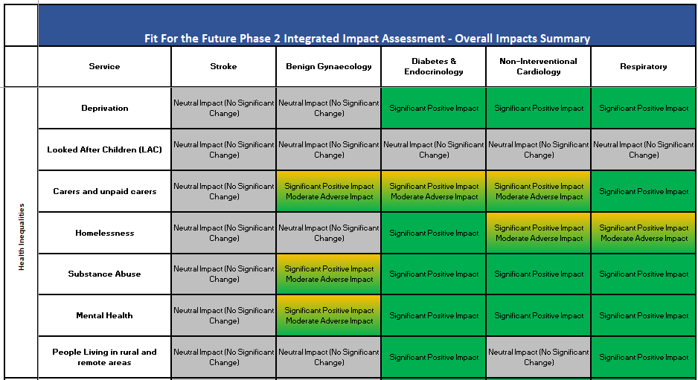

A full Health Impact Assessment (HIA) for each service is provided in the relevant appendices, which includes all data and evidence-based review. The impacts for each HIA domain are presented overleaf; the key indicates the nature of the impact; see key description used above.
Health Inequalities Impact Assessment – Summary of Impact by Service Proposal

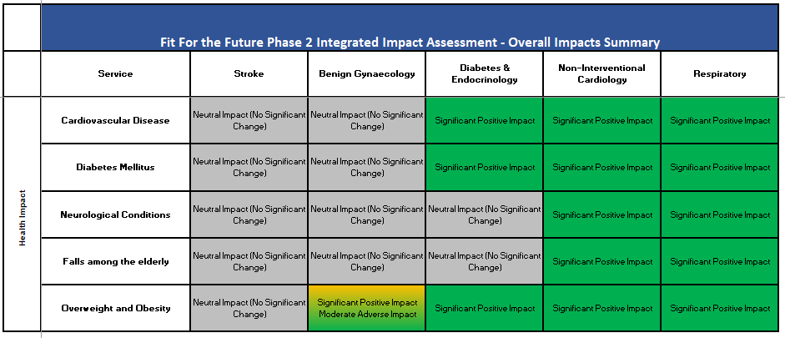

IIA Summary
Full IIAs for each service have been undertaken. In summary the impact assessment for services consolidating on either the CGH or GRH site is often similar including:
- Centralisation of services can improve patient outcomes, continuity of care, length of stay, patient experience and reduces mortality particularly beneficial to patients with protected characteristics including those with long term conditions or co-morbidities which are prevalent in patients with disabilities and those over 65.
- Studies of secondary care usage have found that ethnicity is a significant predictor of acute hospital admission. The district with the highest proportion of ethnic diversity is Gloucester city meaning that a geographical distribution of services to GRH might have a greater positive impact on these communities
- On the basis that there is a higher proportion of the population in the Gloucester district who are living in deprivation (25%) and who suffer from Type 2 Diabetes (6.8%) there is a potential that patients who access the service from Gloucester will be positively impacted by a movement of services to GRH
- The re-location of services from GRH to CGH will impact some patient and carer travel times either positively or negatively (see section Error: Reference source not found for individual service impacts)
- There is no conclusive evidence to suggest that access to and experience of acute hospital care differs solely based on a person's sex.
- There is currently limited data to determine any impact of the changes for women during pregnancy.
- There is currently limited data to ascertain any impact of the changes for those who are from any particular marital status.
- According to the Stonewall survey, 13% of LGBTQ+ people have experienced some form of unequal treatment from healthcare staff because they are LGBTQ+
- There is currently limited data to ascertain any impact of the changes for those who are from any particular religious background.
- There is limited evidence regarding the impact to those who have undergone gender reassignment, however, impacts may mirror those of sexual orientation.
- Caring responsibilities can have an adverse impact on the physical and mental health, education and employment potential of those who care, which can result in significantly poorer health and quality of life outcomes.
- Consolidation of the inpatient bed base should provide shorter lengths of stay, faster diagnostics and minimised waiting times which will help carers who have to attend hospital regularly.
- Services centralising at GRH will be located nearer to the highest proportion of homeless people in Gloucestershire. Homeless people are more likely to have long term conditions and multiple conditions which means consolidating and co-locating services will provide support for more complex needs such as these.
- Mortality rates suggest that the district of Gloucester City has the highest rates of deaths due to substance misuse, significantly higher than county and national averages. Relocation of services may therefore be beneficial to this group.
- GHFT admission data demonstrates that more people attend GRH than CGH with mental health related issues. Relocating services to GRH may therefore be beneficial to this cohort.
- The consolidation of relevant specialist services improves training and enhanced understanding of patient conditions, leading to better clinical outcomes and improving access to services with fewer cancellations
- Feedback from staff and patients suggests parking can be a challenge at both sites.
- Forest of Dean is the only district locally that exceeds the national average in terms of the proportion of residents living with a disability. People with disabilities may have an increased risk of developing secondary conditions that are more likely to result in the need for acute care. This geographical clustering means that geographical changes to where services are delivered may have a disproportionate impact on those with disabilities in terms of access.

Positive Impact: will actively promote the values of the ICB and ensure equity of access to services; Neutral Impact: where there are no notable consequences for any group; Negative Impact: negative or adverse impact for any group. If such an impact is identified, you should ensure, that as far as possible, it is eliminated, minimised or counter balanced by other measures.

