


Equality and Engagement Impact Assessment
Please refer to the Guidance for Completion of the Equality and Engagement Impact Assessment. If you require any assistance in completing this form, please contact the Patient Engagement and Experience team.
Title of service, policy, or programme: | Lung Cancer Clinics, Gloucestershire Hospital NHS Foundation Trust (GHNFT).
Name and job title involved in the completion of this assessment: | Megan Terrett, Programme Manager, Gloucestershire Integrated Care Board (GICB) & GHNFT.  Caroline Smith, Senior Manager, Engagement & Inclusion, GICB.

Date of this assessment:

(It is good practice to undertake an assessment at each stage of the project)
Stage of service, policy or programme change | Development X | Implementation ☐ | Evaluation/review ☐

1. Outline
Give a brief summary of your policy, service or programme. Include reference to the following:  - Is this a new or existing policy, service, or programme?  - If it is not new, detail any proposals for change. | GHNFT has been working with One Gloucestershire partners to oversee and lead on the developments of Gloucestershire’s Community Diagnostic Centre (CDC) which is situated within Quayside House in Gloucester City and offers elective outpatient appointments and diagnostic services.  The GHNFT’s CDC development was initiated from National Diagnostics Programme following the publication of ‘Diagnostics: Recovery and Renewal’, sets out 24 recommendations which would create CDC, separate elective and non-elective work and the resulting increase in equipment, workforce, and use of emerging technologies¹.  As part of Gloucestershire’s CDC Operational Management Workstream, there has been engagement with GHNFT divisions and specialities to pull together proposals for the clinical utilisation of the CDC’s multi-purpose outpatient clinic rooms. It is expected that proposals presented fit the national vision statement for a CDC –  ‘Community Diagnostic Centres will deliver additional, digitally connected, diagnostic capacity in England, providing all patients with a coordinated set of diagnostic tests in the community, in as few visits as possible, enabling an accurate and fast diagnosis on a range of a clinical pathways.’  As result of this engagement, the proposal was put forward to move two lung cancer clinics from Gloucester Royal Hospital (GRH) to Quayside CDC as well as undertake a temporary move of two clinics from Cheltenham General Hospital (CGH) to Quayside CDC. The service will maintain some Lung Cancer clinics at CGH to offer patient choice and in case some service users can’t access Quayside CDC. However, the number of clinic appointments at CGH will be reduced from what is currently available.  The investigations that the service offers/utilises are chest Computer Tomography (CT) scan, Positron emission tomography (PET) scans, tissue biopsies, Bronchoscopy / Endobronchial Ultrasounds (EBUS), CT / Ultrasound guides biopsies and Pleural aspirations. Ideally before being seen at their clinic appointments patients are booked in for a chest CT so the results and further investigations can be discussed, in some cases, full lung function (FLF) tests and are also investigated. Patients are referred by the GP and are required to provide a performance status, recent creatinine level and anticoagulation to allow efficient triaging by the service.  This Equality and Equity Impact Assessment (EEIA) is specific to GHNFT’s Lung Cancer outpatient service but relates to the Community Diagnostics Hubs EEIA completed in 20/01/2022.  References  - https://www.england.nhs.uk/publication/diagnostics-recovery-and-renewal-report-of-the-independent-review-of-diagnostic-services-for-nhs-england/
What aims/outcomes do you want to achieve? | The service aims to deliver the national optimal lung cancer pathway^{2&3}, which specifies that patients should have had their CT scan and 2 week waits clinic appointment by day 6 of their pathway. Further diagnostic and staging investigations should be requested and delivered as bundle in order to deliver treatment Multi-Disciplinary Team (MDT) decision by day 21.  The desired outcomes of this service’s relocation –  - Allows the service to be situated in the locality in which most of their service users and those at risk reside,  - Provides the service with a more frequent and stable clinical space to operate from as GRH clinics are held in the Outpatients Department and are infrequent (ad hoc),  - Service User seen with GRH Lung Cancer clinics at the CDC will be able to access an array of other diagnostic tests onsite as required, in a ‘One Stop Shop’ service model,  - Allows the service to offer more ‘One Stop Shop’ service appointments until the Respiratory Hub at CGH is developed. This will enable the speciality to offer a ‘One Stop Shop’ service model at CGH as well as Quayside CDC,  - Support with the service’s capacity up to and beyond the establishment of their new respiratory hub at CGH which is due to be completed in 2025,  - Quayside CDC enables the service to flexibly and effectively trial ‘One Stop Shop’ service model, before committing to that operating model,  - The movement of the Lung Cancer clinics will enable the speciality to increase clinics for other Respiratory related service, such as asthma clinics.  References  - The National Optimal Lung Cancer Pathway (NOLCP) – PowerPoint Presentation (cancerresearchuk.org)  - Implementing a timed lung cancer diagnostic pathway - implementing-timed-lung-cancer-diagnostic-pathway.pdf (england.nhs.uk).
Give details of any evidence, data or research used to support your work. Consider the following:  - Health Needs Assessment,  - JSNA/Inform data,  - National/regional data,  - Patient experience data. | Cancer Faster Diagnosis Framework  Faster Diagnosis is fundamental to achieving the Long-Term Plan (LTP) ambitions for cancer. The NHS Cancer Programme has developed a Faster Diagnosis Framework, which sets out NHS England and Improvement’s strategic approach to speed up cancer diagnosis and improve patient experience.  The Faster Diagnostic Framework aims to deliver^{4&5}:  - An earlier and faster diagnosis for patients, whether they are diagnosed with cancer or not,  - Excellent patient experience, a holistic assessment of patient needs, and streamlined support across community, primary and secondary care,  - Increased capacity in the system, through more efficient diagnostic pathways,  - Support to healthcare providers to reach the Faster Diagnosis Standard (FDS).  The proposal to move the Lung Cancer clinics from GRH and the temporary move from CGH supports the national ambition stated above, as the Quayside CDC has been purposefully designed to enable patients to access a suit of diagnostic test on one site, on the same day or in as few appointments as possible. It is hoped that streamlining the diagnostic pathway for patients with suspected lung cancer, will lead to earlier disease detection or not, better health outcomes, as well as improvements in patient experience. Furthermore, even though this proposal doesn’t include expansion of the lung cancer workforce it is hoped that due to less time between the required diagnostic tests, the diagnostic pathway will become more efficient and lead to an increase in service productivity.  Risk Factors  The predominant risk factors for lung cancer are listed below^{6,7&8}.  - Smoking,  - Age,  - Previous lung disease,  - Chemical exposure and pollution.  Smoking –  Smoking tobacco is the cause of most lung cancers and the biggest risk factor. This includes smoking cigarettes, cigars and pipes⁶. In the UK, 72% of lung cancer cases are caused by smoking⁶.  In comparison, Gloucestershire’s smoking prevalence within its adult population (11.5%) is statistically lower than regional and nationally averages (Southwest 11.9% and England 12.7%, respectively)⁹. Across the county Gloucester has the highest prevalence of smokers in people over the age of 18 years (18.1%), with Cheltenham being the second highest (12.6%) and Cotswold being the lowest (6.3%)⁹.  Age -  Lung cancer is more common in older people, more than 4 in 10 people (44%) who are diagnosed are aged 75 and over⁶. Lung cancer can affect younger people, but it is rare in anyone under 40⁶.  The 2021 Census states that 21.7% of Gloucestershire population are aged +65 years of age, with the largest age group being the 16-64 years of age (60.8%)¹⁰. Furthermore, across the county at district level Cotswolds has the greatest portion of residence age +65 years (26.1%), closely followed by Forest of Dean (25.1%)¹⁰.  The number of lung cancer registrations between 2017-19 per 100,000 population was 54.4 which in comparison to southwest and national rates is lower (6.5.5 & 77.1, respectively)¹². Across Gloucestershire between 2017-2019, Gloucester had the highest number of Lung Cancer registration (74.4 per 100,000 population), the second highest being Cheltenham (56.1 per 100,000 population) and Cotswold being the lowest (43.8 per 100,000 population)¹².  Similar trends are seen in Gloucestershire for the under 75 years mortality rate for Lung Cancer (16.4 per 100,000 population) which again is lower than the regional and national rates (22.6 & 26.0 per 100,000 population)¹¹. At district level the mortality rate for those who were aged under 75 years of age is highest in Gloucester (133.1 per 100,000 population), with the lowest being Cotswold (10.28 per 100,000 population)¹¹. Across all ages, Gloucestershire’s mortality rate is 33.7 per 100,000 population, which is lower than the regional and national rates (42.5 & 48.5 per 100,000 population)¹¹. At District level Tewkesbury has the highest mortality rate for lung cancer (44.8 per 100,000 population) followed by Gloucester (40.7 per 100,000) and Cotswold with the lowest in the county (24.6 per 100,000 population)¹¹.  Previous Lung Disease –  Previous lung diseases can increase your risk of lung cancer. Your risk of lung cancer is higher if you have Chronic Obstructive Pulmonary Disease (COPD), Idiopathic pulmonary fibrosis (IPF) or pneumonia compared to people who don’t have it⁷.  Across all ages Gloucestershire prevalence of COPD is 1.8% of the county’s population which is similar to the national prevalence (1.9%). At district level Forest of Dean has the highest prevalence of COPD (2.2%) followed by Tewkesbury and Gloucester (1.9%).  Local information on IPF and pneumonia currently not available.  Chemical exposure and pollution –  Air pollution can cause lung cancer, but this risk depends on the levels of air pollution someone is regularly exposed to⁷. At UK levels, the extra risk for each person is likely to be small⁷. The exposure to outdoor air pollution causes around 1 out of 10 (10%) lung cancer cases in the UK⁷. Furthermore, exposure to certain chemicals and substances which are used in several occupations and industries may increase your risk of developing lung cancer⁸. However, smoking causes around nine times more lung cancer cases than outdoor air pollution⁷.  Service User Demographics  The below information is service level data from Lung Cancer clinics between 2022-23 financial year, and demonstrated the various demographics of people who used that service in year. The total number of service user’s seen by the Lung Cancer clinics in 2022-23 was 858.  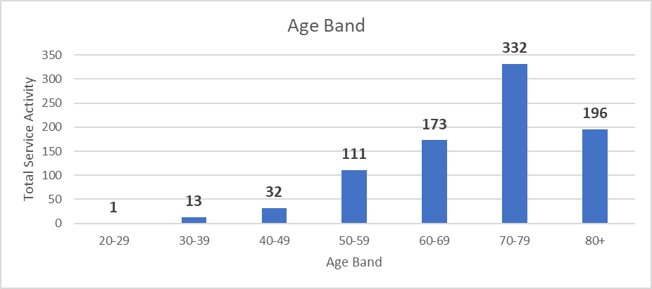  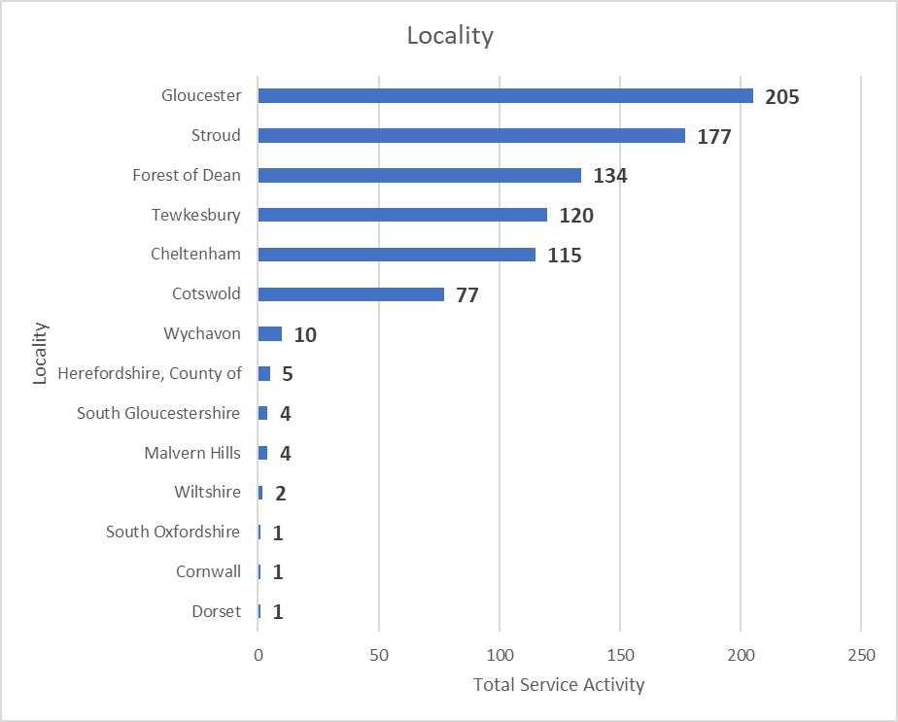  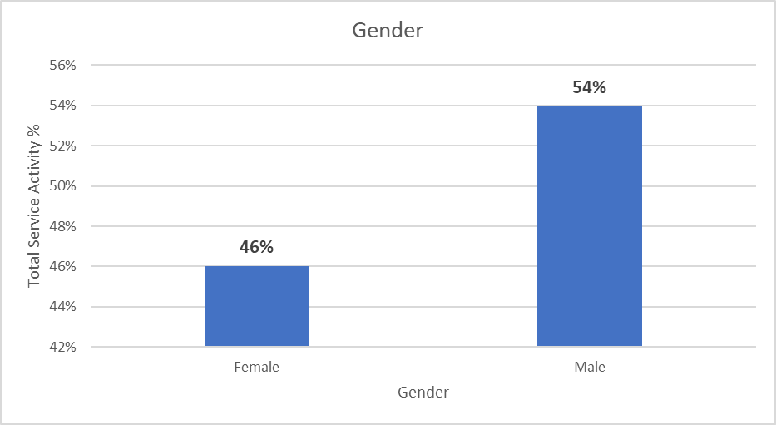  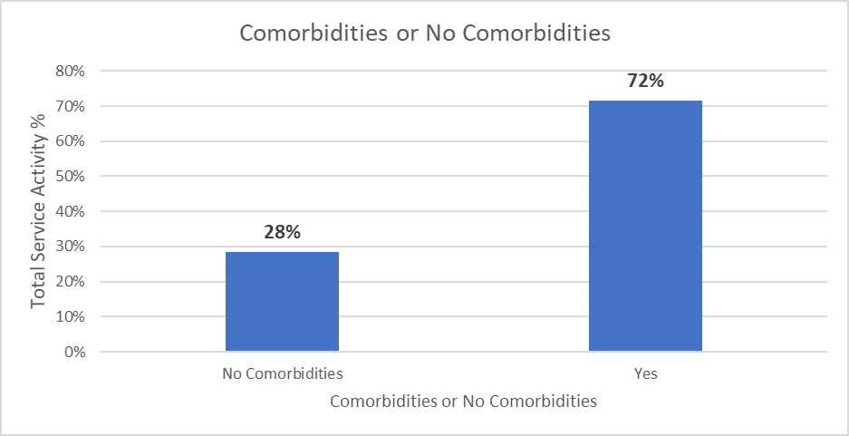  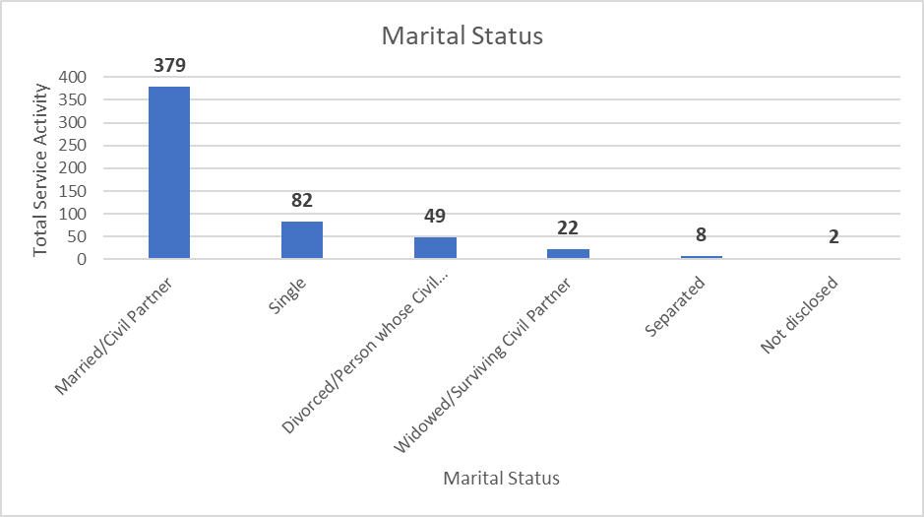  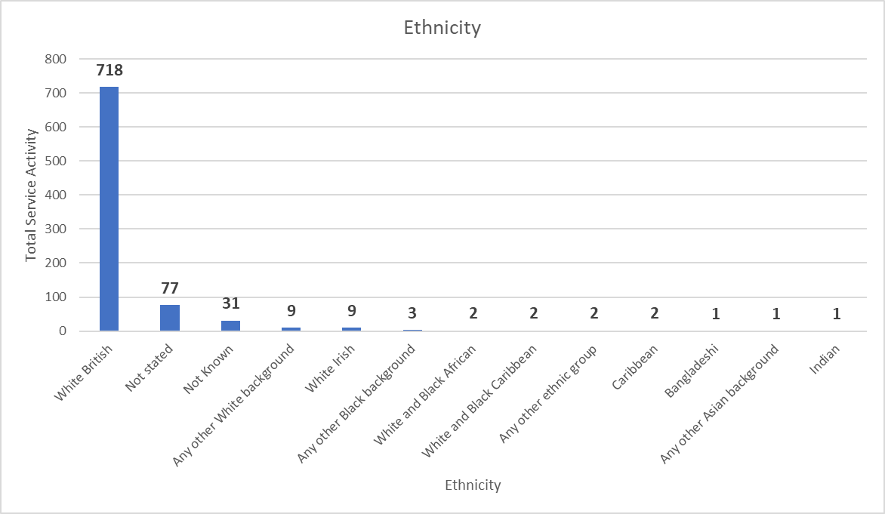  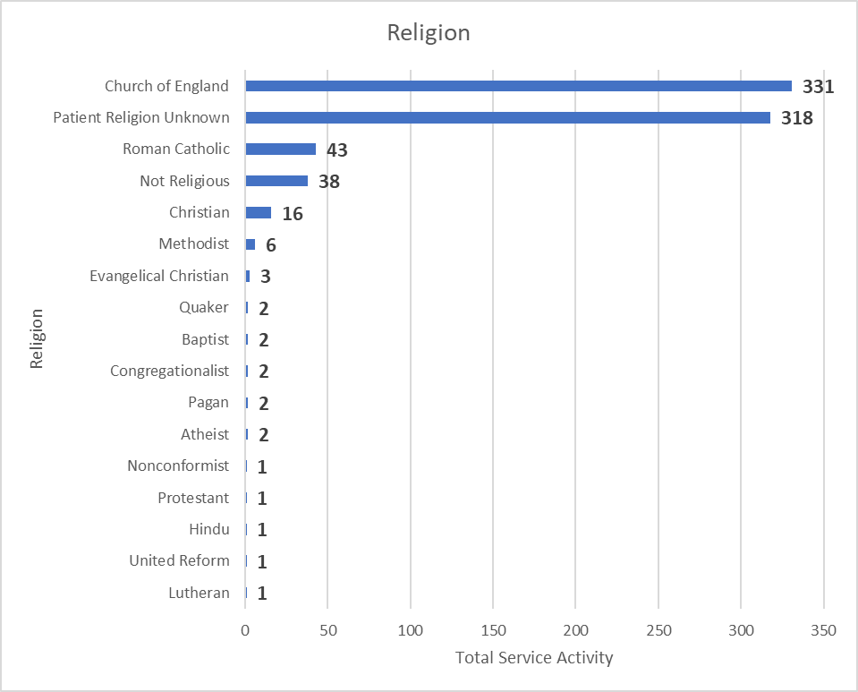  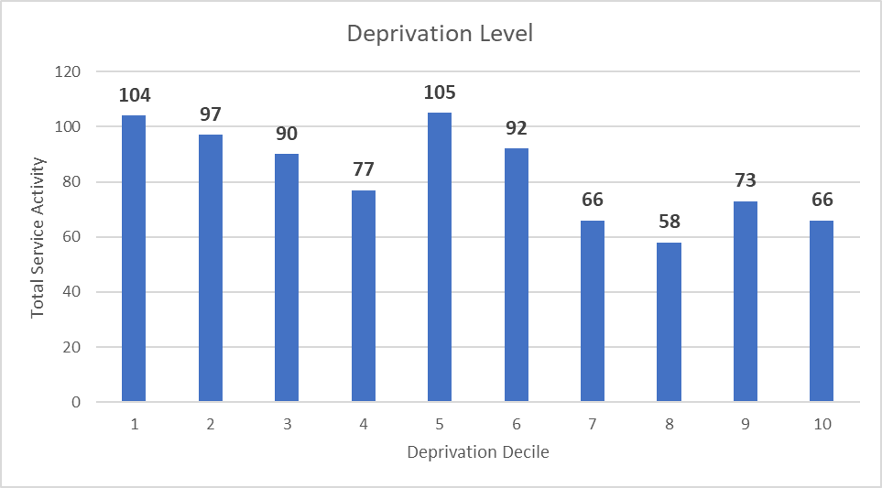  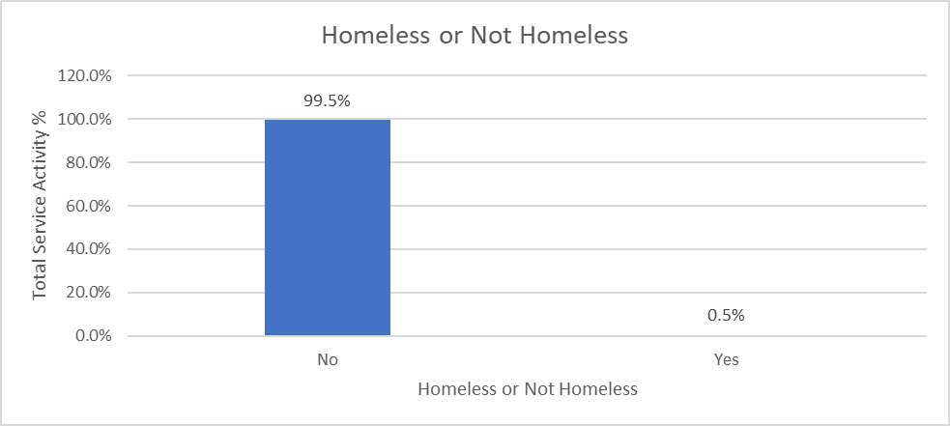  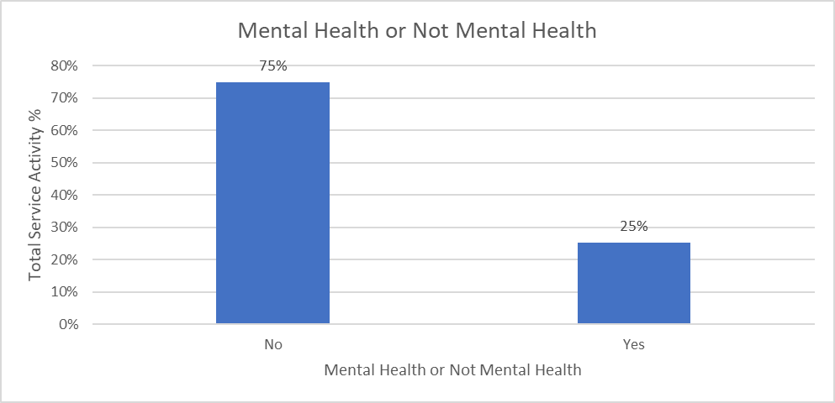  Travel Impact Assessment  As part of Gloucestershire ICB’s impact assessment of the Lung Cancer service relocation, the CSU had been commissioned by the ICB to undertake a travel impact assessment (TIA) to determine the potential impacts that the service relocation could have on service users travel time. The outputs from the TIA report are shared below. Baseline service user data from 2022/23 was used to undertake the analysis.  GRH clinic relocation –  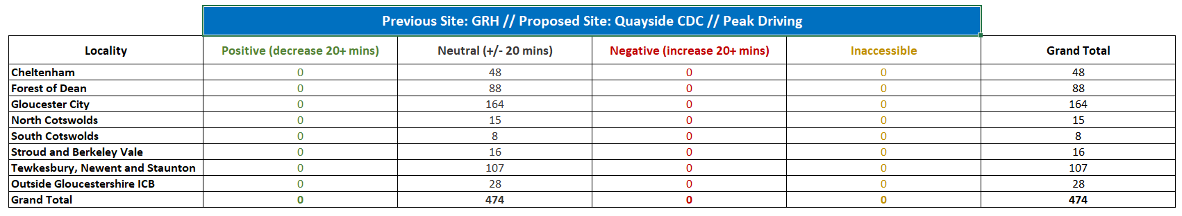  Table 1: Demonstrates the number of service users’ travel split by locality that would be positively and negatively impacted as well as those neutrally impacted when comparing travel to GRH and Quayside CDC at peak times.  Figure 1: A county map depicting the number of service users’ travel split by locality that would be positively and negatively impacted as well as those neutrally impacted when comparing travel to GRH and Quayside CDC at peak times.  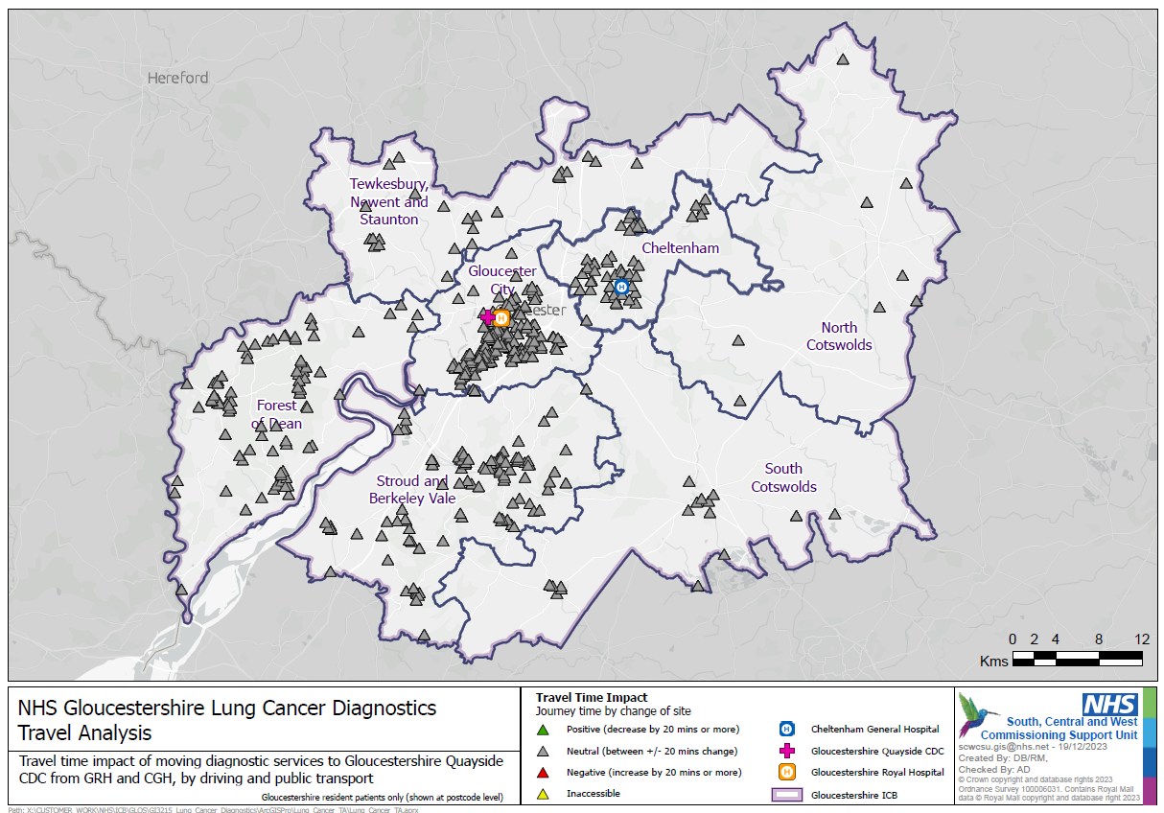  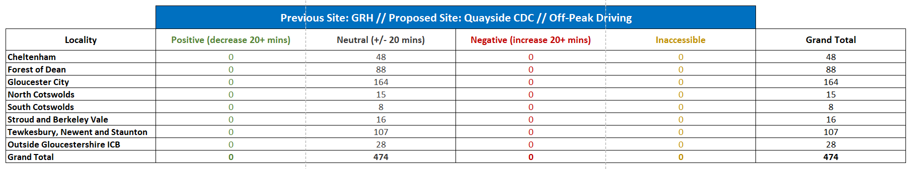  Table 2: Demonstrates the number of service users’ travel split by locality that would be positively and negatively impacted as well as those neutrally impacted when comparing travel to GRH and Quayside CDC at off-peak times.  Figure 2: A county map depicting the number of service users’ travel split by locality that would be positively and negatively impacted as well as those neutrally impacted when comparing travel to GRH and Quayside CDC at off-peak times.  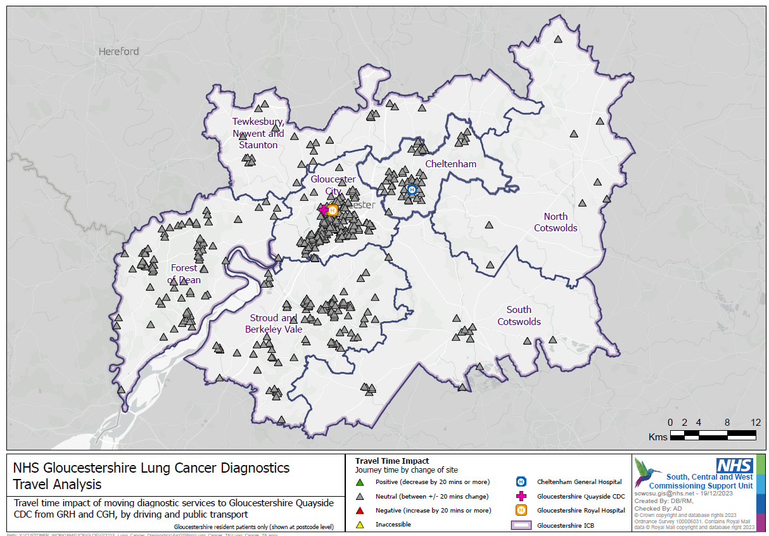  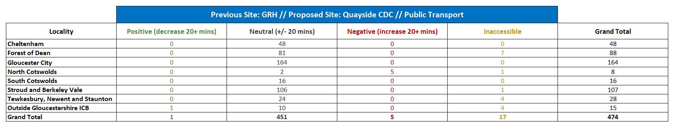  Table 3: Demonstrates the number of service users’ travel split by locality that would be positively and negatively impacted as well as those neutrally impacted, or transport wasn’t accessible when comparing travel to GRH and Quayside CDC if public transport was required.  Figure 3: A county map depicting the number of service users’ travel split by locality that would be positively and negatively impacted as well as those neutrally impacted, or transport wasn’t accessible when comparing travel to GRH and Quayside CDC if public transport was required.  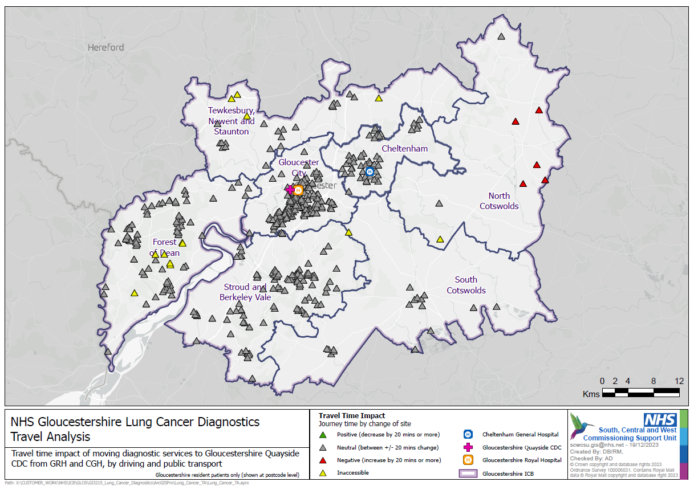  CGH clinic relocation –  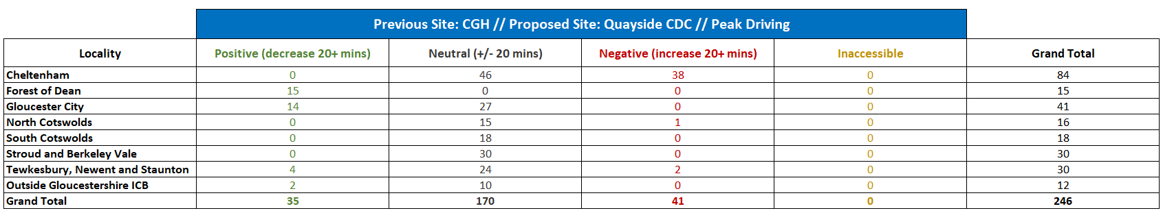  Table 4: Demonstrates the number of service users’ travel split by locality that would be positively and negatively impacted as well as those neutrally impacted when comparing travel to CGH and Quayside CDC at peak times.  Figure 4: A county map depicting the number of service users’ travel split by locality that would be positively and negatively impacted as well as those neutrally impacted when comparing travel to CGH and Quayside CDC at peak times.  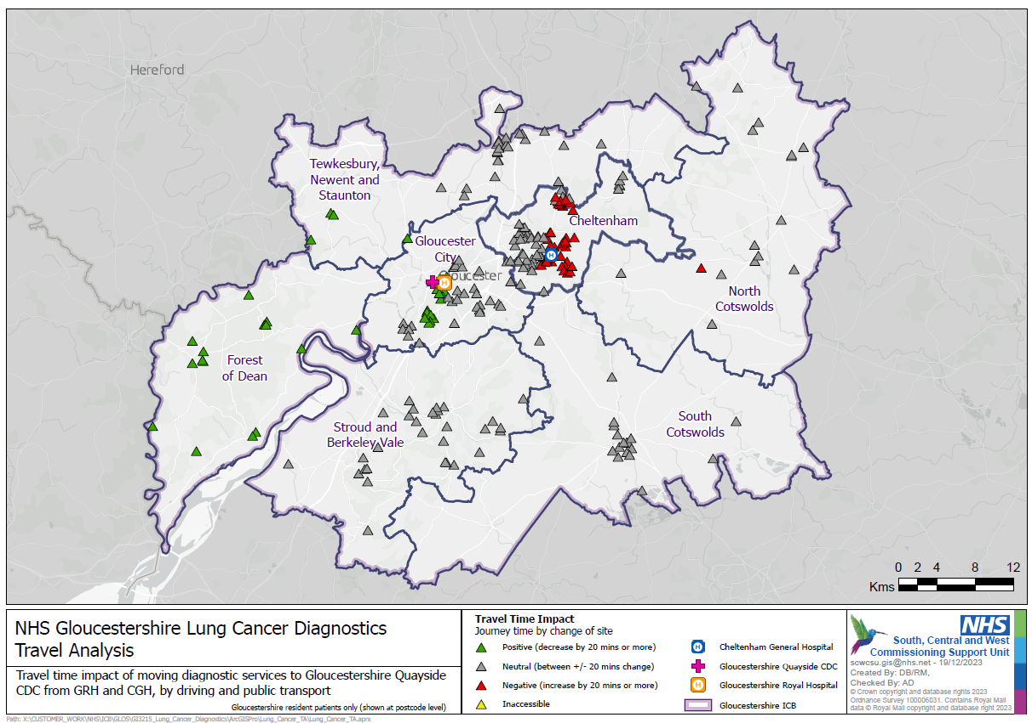  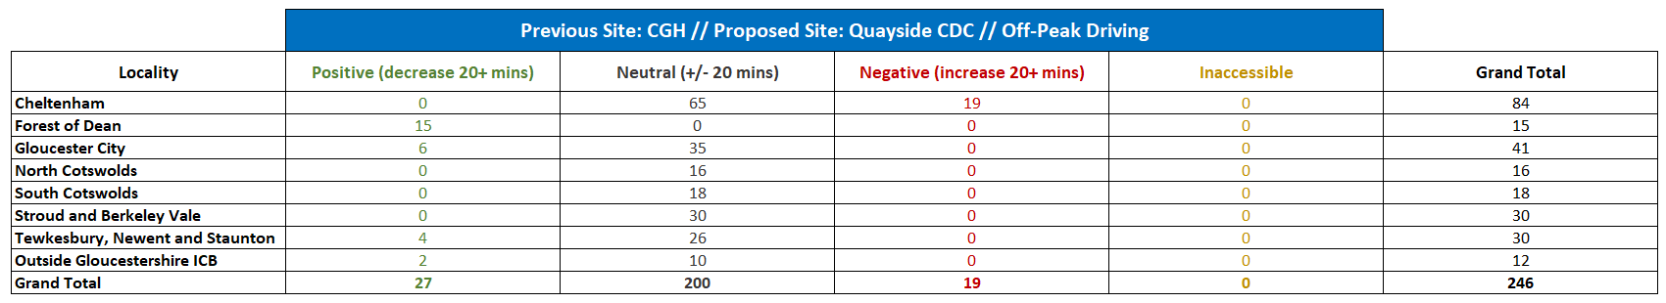  Table 5: Demonstrates the number of service users’ travel split by locality that would be positively and negatively impacted as well as those neutrally impacted when comparing travel to CGH and Quayside CDC at off-peak times.  Figure 5: A county map depicting the number of service users’ travel split by locality that would be positively and negatively impacted as well as those neutrally impacted when comparing travel to CGH and Quayside CDC at off-peak times.  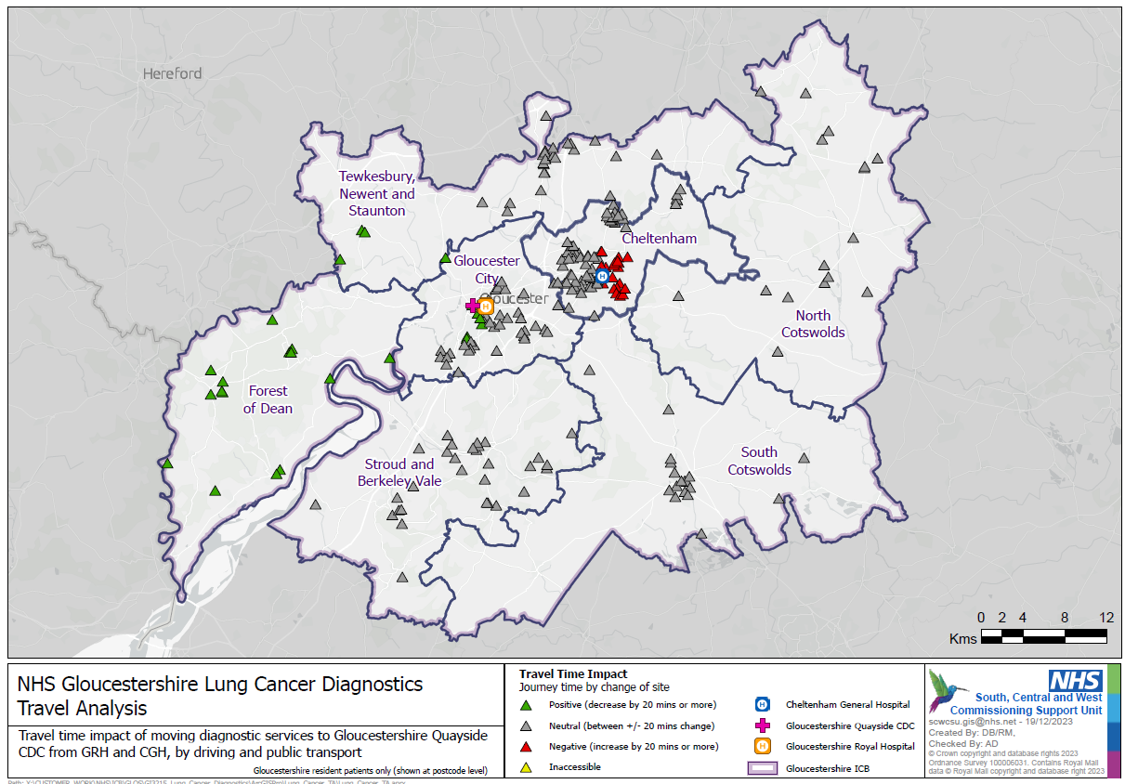  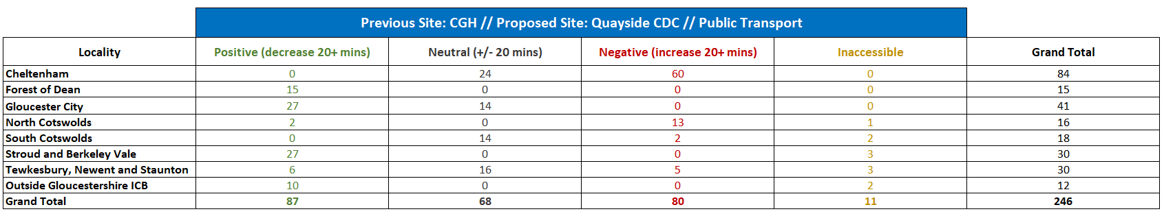  Table 6: Demonstrates the number of service users’ travel split by locality that would be positively and negatively impacted as well as those neutrally impacted, or transport wasn’t accessible when comparing travel to CGH and Quayside CDC if public transport was required.  Figure 6: A county map depicting the number of service users’ travel split by locality that would be positively and negatively impacted as well as those neutrally impacted, or transport wasn’t accessible when comparing travel to CGH and Quayside CDC if public transport was required.  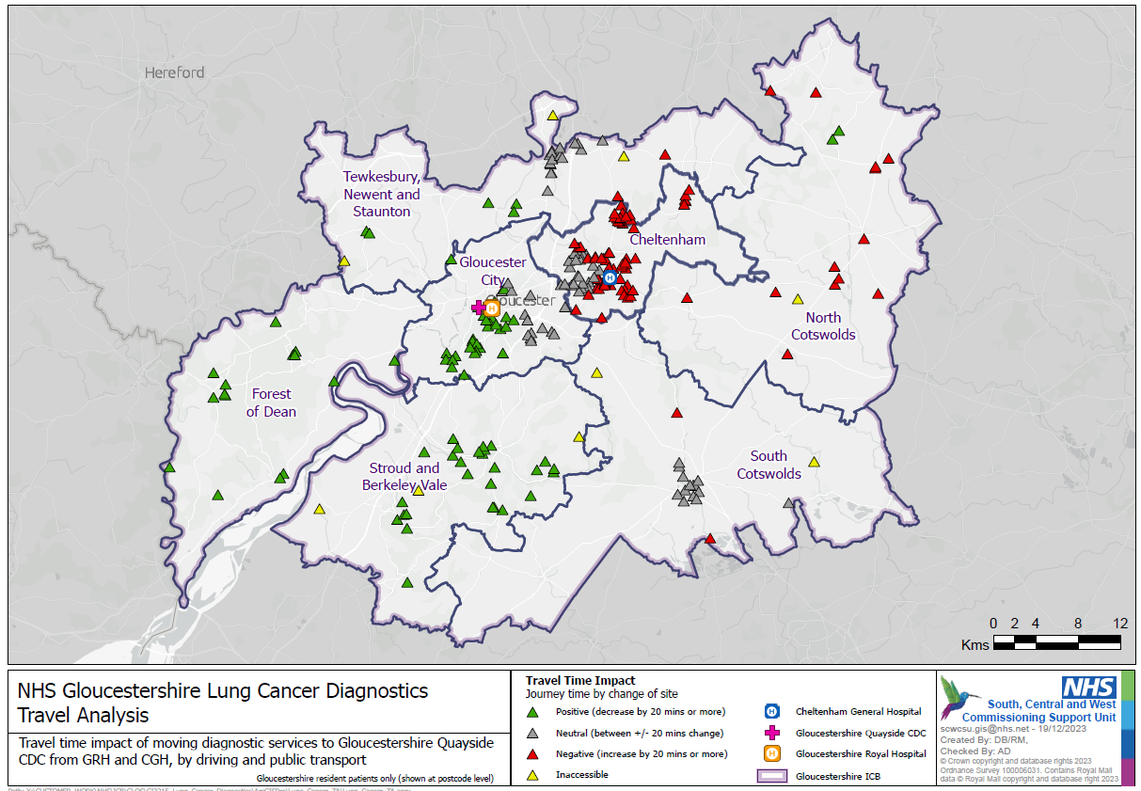  TIA Summary -  The TIA data presented above demonstrates the travel time for the majority of those patients who were seen by the service in 2022-23 at the GRH clinic would have had a neutral impact if their appointment had been at Quayside CDC when travelling at peak, off-peak times or travelling via public transport. Similarly, the majority of those patients who were seen at the service’s CGH clinic and were travelling at peak and off-peak times would have had a neutral impact, whereas those travelling via public transport would have a positive impact on their travel time.  Therefore, due to the predominantly neutral impact on travel time for most as well as the potential of reducing the number of associated appointments that patients would need to attend due to implementing a ‘One Stop Shop’ service model. The relocation of GRH lung cancer clinics to Quayside CDC should be considered positive impact, especially as the service will maintain some clinic activity at CGH increasing patient choice.  References  - NHS England » Faster diagnosis  - B1332-NHS-Cancer-Programme-Faster-Diagnosis-Framework-v5.pdf (england.nhs.uk)  - Causes and risk factors of lung cancer | Macmillan Cancer Support  - Risks and causes of lung cancer | Cancer Research UK  - https://www.nhs.uk/conditions/lung-cancer/causes/  - Public health profiles - OHID (phe.org.uk)  - Demography-and-migration-briefing-v3.pdf (gloucestershire.gov.uk)  - Public health profiles - OHID (phe.org.uk)  - Public health profiles - OHID (phe.org.uk)  - Public health profiles - OHID (phe.org.uk)

2. Engagement
What relevant patient experience data/feedback is already available?  Include information from any relevant national/regional patient groups, eg. Healthwatch, national surveys | During late November/early December 2021, engagement staff visited both acute and community hospital sites to encourage patients to complete a survey giving feedback on their experience of current diagnostic services and share their views on priorities for future service delivery. Full outcomes of this engagement are included in the attached report.  Report highlights  There were 95 responses to the survey. Overall, there is high satisfaction with existing services. The key findings are:  - 64% were not offered choice of appointment, but 84% of these agreed the location of their test was easy to get to,  - 28% reported longer than expected wait for test,  - 49% received their results quickly,  - Most patients understood why they were having test (86%) and what was involved (88%),  - 26% patients wanted more information, with 20% saying they did not understand the results of their test(s).  Top 3 ranked factors that were important to people when having diagnostic tests:  - Receiving results on the same day, or as quickly as possible afterwards,  - Shorter waiting times – between the time of referral and diagnostic test,  - Joined up care: communication between healthcare teams: GP, hospital, and community teams.  Furthermore, Gloucestershire ICB and GHNFT are required to partake in the NHSE’s patient Experienced Based Design (EBD) approach which aims to understand how patients ‘felt’ at each stage of their journey and to identify areas for improvement to improve the patient experience at CDCs. Below is attached the patient EBD report March 2024.  The purposed movement of Lung Cancer clinics from GRH and temporary partial movement of some of the clinics at CGH to Quayside CDC, supports the findings of the initial engagement i.e., maintains choice of location, reduction in time to receive a diagnostics test through implementing a ‘One Stop Shop’ model, and therefore a reduction in the time to receive test results/diagnosis.
How have patients, carers and families, staff been involved in shaping your proposals.  If your policy/programme is currently being developed, please explain any further plans for engagement and/or consultation.  (*Plans for additional engagement should also be included in the Section 5: Action Plan below) | CDC Engagement -  During the winter 21/22, the engagement team carried out staff and patient surveys in connection with the development of CDC. The aim was to understand the views of staff working within existing diagnostic services and the experiences of patients using diagnostic services from across Gloucestershire.  Engagement methodology  A Communication and Engagement Plan was developed to support the work of the Diagnostic Programme Board. The plan identified the need to undertake some early engagement with patients using, and staff working within, diagnostic services in Gloucestershire. Feedback collected will inform the development of a business case for a CDC in the county.  Patient engagement -  During late November/early December, engagement staff visited both acute and community hospital sites to encourage patients to complete a survey giving feedback on their experience of current diagnostic services and share their views on priorities for future service delivery. The survey was available on-line and in paper copy (with FREEPOST address for return).  Staff at the clinics were also asked to promote the questionnaire to patients and posters featuring a QR code linking to the survey were displayed in diagnostic clinics in acute and community hospital settings. In addition, the questionnaire was available on the Get Involved in Gloucestershire engagement platform and publicised via social media and with key stakeholders/local patient networks.  People were asked to provide feedback on access to services, patient information, and communication/results, together with ideas for improvement and future priorities.  Engagement with staff -  Staff working across the range of diagnostics services, including primary care, were asked to complete a short on-line survey which focused on their ideas for improving service delivery and patient experience. Staff were also asked to rank the core requirements set out for CDCs in order of priority for Gloucestershire during 2021/2022.
If your plans/policies are implemented, please explain:
Any impact on the way in which services are delivered?  eg. change in location, frequency of appointments. | - Some of the CGH Lung Cancer clinics temporary relocating from CGH to Quayside House in Gloucester City, and permanent relocation of the GRH to Quayside House. A Travel Impact Analysis has been undertaken to assess the level of impact that the relocation has on the likely service users, using baseline service user locations from 2022/23 data.  - The number of appointments which the Lung Cancer team can offer will be sustained despite the scheduled building works at CGH if the proposed temporary move to Quayside goes ahead.
Any impact on the range of health services available? | - Service User seen with Lung Cancer clinics at the CDC will be able to access an array of other diagnostic tests onsite as required, in a ‘One Stop Shop’ service model. As these other diagnostic modalities at the CDC will be dedicated to elective activity, this should minimise the number of separate visits/appointments prior to diagnosis being determined.
Have you considered whether any change could be considered significant variation? If yes, formal public consultation will be required (See Guidance or ask your Engagement Team for advice). | Given the activity data held, the majority of patients accessing the Lung Cancer Clinic are likely to benefit from the relocation to the CDC. The impact of this change on all patients is likely to be small as patients typically visit the service twice during their care. The service is maintaining some of their clinics at CGH and the pathway for onward care and treatment will remain unchanged, however the service will need to consider how they are going to communicate the clinics location choice to patients. The engagement undertaken will be appropriate to the level of service change described.

3. Equality considerations
This is the core of the Equality Impact Analysis; what information do you have considered any potential or existing impact on protected groups, as defined by the Equality Act 2010. Consideration should also be given regarding wider inequalities that people may experience because of social, domestic, environmental and economic circumstances, eg. unpaid carers, rural isolation, areas of deprivation. If your proposals contain more than one solution for service delivery, you should consider the potential impact for each of the solution in this section.
(Please complete  each area) | What key impact have you identified at this stage? |  |  | Explain any positive or negative impact below. What action, if any, has been taken to address these issues? | Further action required?  (*Include details in Section 5: Action Plan below)
(Please complete  each area) | Positive  Impact | Neutral  impact | Negative  Impact
Age | ☐ | X | ☐ | Lung cancer is more common in older people, more than 4 in 10 people (44%) who are diagnosed are aged 75 and over⁶. Lung cancer can affect younger people, but it is rare in anyone under 40⁶.  Across the county at district level Cotswolds has the greatest portion of residence age +65 years (26.1%), closely followed by Forest of Dean (25.1%)¹⁰. However, Gloucester had the highest number of Lung Cancer registration (74.4 per 100,000 population, 2017-19)¹² and the mortality rate for those who were aged under 75 years of age is highest in Gloucester (133.1 per 100,000 population)¹¹.  Therefore, the impact of the proposed service relocation could be considered neutral as it will remain be situated in the localities with the populations greatest risk and accessible to all adults in Gloucestershire.
Disability | ☐ | ☐ | X | There is no data that demonstrations that someone who has a disability puts them that greatest risk of developing lung cancer.  However, Quayside CDC isn’t equipped to see people who aren’t considered ambulatory, therefore those patients who are bedridden aren’t able to access the service at Quayside CDC. The Lung Cancer service will make separate arrangements for these people to be seen in more acute settings such as CGH.
Gender reassignment | ☐ | X | ☐ | There is no data that demonstrations that someone who has had a gender reassignment puts them that greatest risk of developing lung cancer.  Furthermore, as the Lung Cancer diagnostic service will remain located in localities with population who have the greatest risk factors and being accessible to anyone regardless of gender, therefore impact of this clinic relocation could be considered neutral.
Marriage and civil partnership | ☐ | X | ☐ | There is no data that demonstrations that someone’s marital status puts them that greatest risk of developing lung cancer.  Furthermore, as the Lung Cancer diagnostic service will remain in localities with population who have the greatest risk factors and being accessible to anyone regardless of marital status, therefore impact of this clinic relocation could be considered neutral.
Pregnancy and maternity | ☐ | X | ☐ | There is no data that demonstrations whether someone is pregnant puts them that greatest risk of developing lung cancer.  Furthermore, as the Lung Cancer diagnostic service will remain in localities with population who have the greatest risk factors and being accessible to anyone regardless of pregnancy status, therefore impact of this clinic relocation could be considered neutral.
Race | X | ☐ | ☐ | Office of National Statistics reported that nationally in 2022 those from a mixed ethnicity had the highest percentage of smokers (17%)¹⁴. Locally Gloucester City is greatest prevalence for smokers⁹ as well as greatest number of residences who are from a mixed ethnicity¹⁵.  Therefore, it could be said that the proposed clinic relocations would have a positive impact on the race that is mostly likely to participate in health/lifestyle behaviours that put them at greater risk of developing lung cancer.
Religion or belief | ☐ | X | ☐ | There is no data that demonstrations whether someone’s faith puts them that greatest risk of developing lung cancer.  Furthermore, as the Lung Cancer diagnostic service will remain in localities with population who have the greatest risk factors and being accessible to anyone regardless of their faith, therefore the impact of this clinic relocation could be considered neutral.
Sex | ☐ | X | ☐ | Someone’s gender is not considered a significant risk factor for developing Lung Cancer. There is greater prevalence of associated risk factors such as COPD diagnosis is higher in men (19% standard rate) who live in Gloucestershire in comparison to women (17% standard rate)¹⁶.  Nonetheless, the service will be in localities with population who have the greatest risk factors and being accessible to anyone regardless of sex, therefore impact of this clinic relocation could be considered neutral.
Sexual orientation | ☐ | X | ☐ | There is no data that demonstrations that someone’s sexual orientation puts them that greatest risk of developing lung cancer.  Furthermore, as the Lung Cancer diagnostic service will remain in localities with population who have the greatest risk factors and being accessible to anyone regardless of sexual orientation, therefore impact of this clinic relocation could be considered neutral...
Other considerations | X | ☐ | ☐ | Across the county Gloucester has the highest prevalence of smokers in those above the age of 18 years (18.1%), with Cheltenham being the second highest (12.6%) and Cotswold being the lowest (6.3%)⁹.  Therefore, having a ‘One Stop Shop’ lung cancer service operating in the locality that has the greatest number of people smoking which is the biggest risk factor associated with lung cancer should be considered a positive impact for this population will have better timely access to diagnostic services and tests.
Other considerations: please consider, and identify, those who face health inequalities e.g., areas of deprivation, people with poor mental health, social/rural isolation, people who misuse drugs and/or alcohol, people who are homeless, sex workers, etc
References
- https://www.ethnicity-facts-figures.service.gov.uk/health/alcohol-smoking-and-drug-use/adult-smokers/latest/
- equality-profile-2024-refresh.pdf (gloucestershire.gov.uk)
- ICBBI0026 - Demographic and Population Analysis - Power BI

4. Monitoring and review
If you are at the implementation or evaluation stage of your policy development/service or programme change:
Has an earlier Impact Assessment been undertaken? | Yes X | No ☐ | N/A ☐
If yes, please include details of any action plan below:
What issues/actions have previously been identified? | The CDC EIA (2021) stated a need to gather patient feedback on existing diagnostic services. Cycles of Experience Based Design (EBD) is required by each CDC with outputs and action plans reported to national CDC programme. Patients who are seen at the CDC Lung Cancer clinics will be able to feedback on the experience as part of the EBD work.
Are any further actions required?

5. Action Plan
Issues/impact identified in Section 2, 3 or 4 above | Explain any further actions required | How will you measure and report impact/progress | Timescale for completion
Service relocation | A Travel Impact Analysis is to be undertaken to assess the level of impact that the relocation has on the likely service users, using baseline service user locations from 2022/23 data. | The impact of Lung Cancer clinic relocation will be included in the CDC’s overall benefits realisation work. | Complete.
Staff and patient engagement | Engagement with patients will comprise of a letter to existing informing them a change of appointment location if appointment was scheduled at GRH. Patient with appointments scheduled at CGH will be given the option to keep appointment at CGH or move to Quayside CDC, this will apply to new patients also. |  | September 2024
When will the proposal be next reviewed? | Annually in line with the Gloucestershire CDC planning.

6. Completion: | Name and Job title | Date
Completed by: | Megan Terrett, Senior Project Manager, NHS Gloucestershire ICB
Equality Lead: | Caroline Smith, Senior Manager, Engagement & Inclusion, NHS Gloucestershire ICB
Project Sponsor: | Kerry O’Hara, Associate Director – Clinical Programmes, NHS Gloucestershire ICB
Policy/programme signed off by:
(E.g., Governance and Quality, Governing Body, etc)

Positive Impact: will actively promote the values of the ICB and ensure equity of access to services. Neutral Impact: where there are no notable consequences for any group. Negative Impact: negative or adverse impact for any group. If such an impact is identified, you should ensure, that as far as possible, it is eliminated, minimised or counterbalanced by other measures.

