Fit for the Future 2
Ideas for special health services in Gloucestershire.

Who we are,
One Gloucestershire Integrated Care System is a group or partnership between NHS health and care organisations.
Who is in the One Gloucestershire group or partnership?
- NHS Gloucestershire Clinical Commissioning Group
- GP’s
- Gloucestershire Health and Care NHS Foundation Trust
- Gloucestershire Hospitals NHS Foundation Trust
- South Western Ambulance Service NHS Foundation Trust
We work together to keep people healthy by making sure there are good health services in the community and in hospitals.
Please read this information and tell us what you think about our ideas.
You can fill in our survey online
https://getinvolved.glos.nhs.uk/
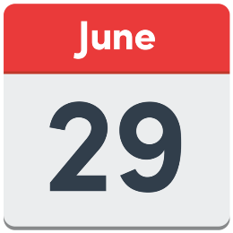
Or fill it in on paper and send it back to us between 17 May and 29 June 2022.
There will be other chances to have your say during the summer.

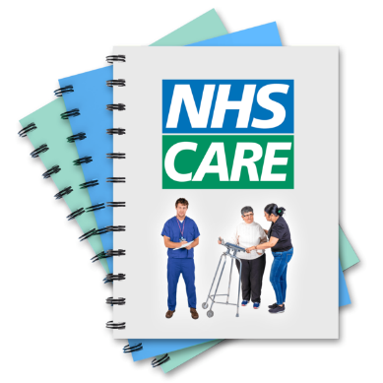
What is Fit for the Future 2 about?
Fit for the Future 1 was about how we organise our special services in hospitals.
Fit for the Future 2 is about working together to agree how we organise other special health services in Gloucestershire.

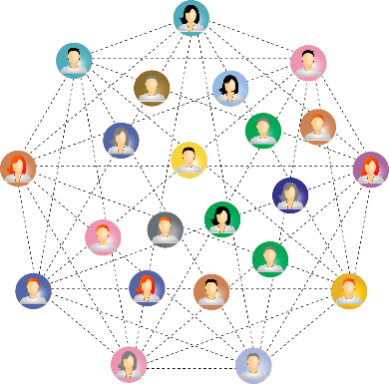
We are looking at how we can give people the best care for their illness or injury.

We want to join up care between things like hospitals, GP’s and health and social care services.

We want to make sure good health care is there for everyone.
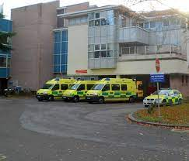
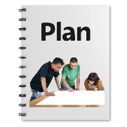
Fit for the Future 2 is not about saving money.

It is not about the things we have already decided on in Fit for the Future 1.

It is not about changes to the Accident and Emergency Department in Cheltenham.
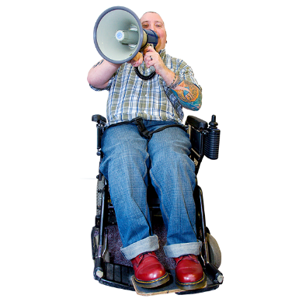
We want to hear from people who are interested in what happens with the health services in this booklet, especially.
people who have used the services,
people who might be affected by the ideas we have,
people who haven’t told us what they think before.

Our ideas for special health services.
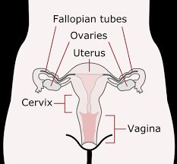
Benign Gynaecology – Day Cases.
Benign means not cancerous.
Gynaecology is about the health of the parts of a woman involved with having babies.
Day cases are health things that do not need a person to stay in hospital overnight.
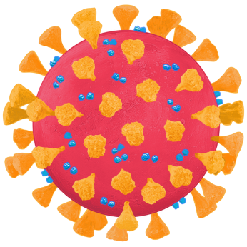
Most gynaecology day cases used to be at Gloucestershire Royal Hospital (GRH).
During Covid-19 more of them happened at Cheltenham General Hospital (CGH).
Our Ideas.
Carry on doing most day cases at CGH.
Carry on having a choice for people who need to go to the hospital for special appointments or clinics, these are called outpatient appointments.

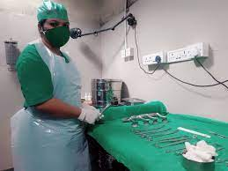
What this means.
There will be fewer operations cancelled.

People can use the new Day Case Unit at CGH.

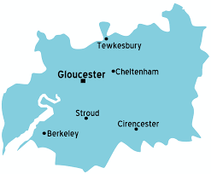
There would be more operations done so women can have surgery sooner.

Some people might have to travel further but only on the day of their operation.
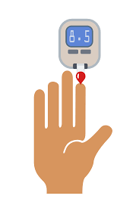
Diabetes and Endocrinology.
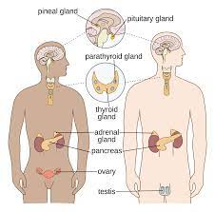
Diabetes is a serious condition where a person’s blood sugar gets too high because there body does not make enough or any insulin.
Endocrinology is about the endocrine system which makes your body’s hormones.
Hormones are your body's chemical messengers. They travel in your bloodstream to tissues or organs.
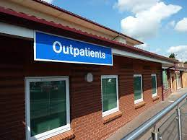
Mostly people have outpatient appointments, but some people do stay overnight.

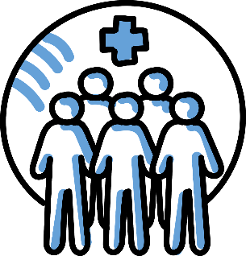
Before Covid-19 there were 26 beds across GRH and CGH. We have worked out we need 14 – 18 beds.
At GRH we have 14 special beds for diabetes and endocrinology.

We have a small team of specialist staff who cover lots of different places.
Our Ideas.
Carry on having special services at GRH.
Carry on having a choice for outpatient appointments.
What this means.
We can manage staffing and staff training better.
More specialist staff in one place who can work with other health staff.
Some people will have to travel further.

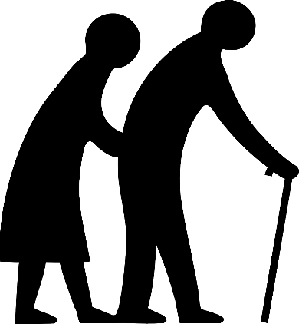
Frailty/Care of the Elderly.
Frailty is when a person cannot fight off illness or get better quickly when they have been ill.
Frailty is mostly something that happens when we get older, but it can affect younger people too.
There are lots of services that support people when they are frail including GP’s and community services.
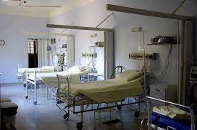
Gloucestershire Hospitals Trust have specialist staff to care for people who are frail.
We have 3 Care of the Elderly (COTE) wards at GRH and one at CGH.
Our Ideas.
We have set ourselves goals to help people get the care they need at home which we think is often much better than a long stay in hospital.
We are working on something called Frailty Virtual Wards, this uses technology and medical devices to help people get the care they need where they live.
We will work on our COTE services at GRH, so we have 2 wards together with a Frailty Assessment unit.
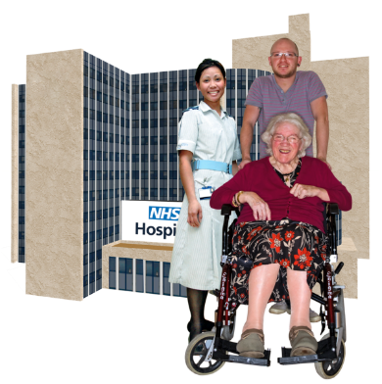
We are thinking about what extra services we could have at CGH.

What this means.
People get support to stay at home as long as possible.
People get assessments quicker and spend less time in hospital.
People get support to go home safely after being in hospital.
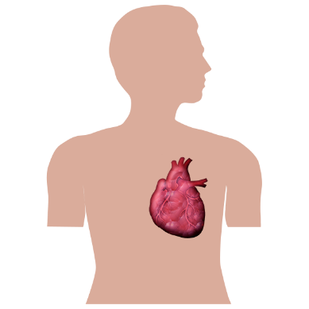
Non-interventional Cardiology.
Cardiology is about treatment for your heart and bold vessels.
There are lots of different health staff who work as part of this service.
Cardiology services are at GRH and CGH for both outpatients and people who are inpatients and need to stay overnight.
Our plan agreed in Fit for the Future 1 is to move most of the inpatient beds to GRH.
Our Ideas.
We think the rest of the beds at CGH could move to GRH.

If people in CGH for other things need help about their heart they can see consultant who specialises in cardiology.
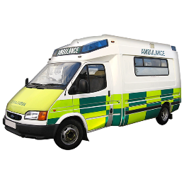
What this means.
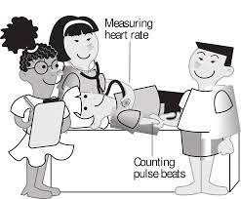
People will not need to move between hospitals to get the care they need.
People will get assessments from the right specialist staff.
It will be easier to manage when staff are sick.
Doctors can have extra training.
People will be in special heart wards.
Some people will have to travel further.

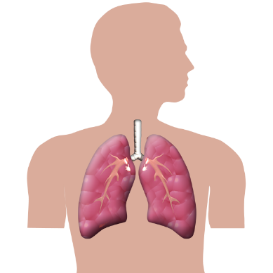
Respiratory.
Respiratory Services help people who have breathing problems.
Before Covid-19 there were inpatient beds at GRH and CGH for respiratory illnesses.
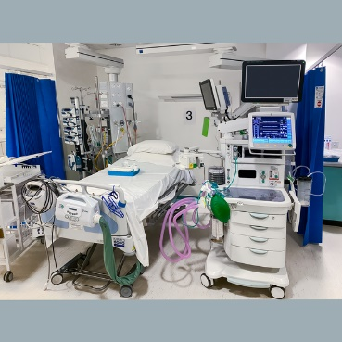
During Covid-19 we had a special ward for people with Covid-19 so we could treat their breathing problems.

At the moment most people who have problems with their breathing are treated at GRH.
Our Ideas.
Because of Covid-19 most of our respiratory services are at GRH.
Our idea is to carry on having a special respiratory service at GRH.

Outpatients will still be able to choose to go to GRH or CGH.

What this means.
It will be easier to have the right specialist staff in the right place.
We can work better with other specialist teams.
Our specialist team at GRH will still support CGH for people who might need and assessment or treatment.
Some people will have to travel further.
It will cost money to carry on having a special respiratory service.

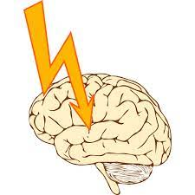
Stroke.
A stroke happens when blood does not get to part of the brain. It is very serious.
Most people who arrive at hospital with a stroke go to the Hyper Acute Inpatient Stroke Unit (HASU) for up to 72 hours.
They then might go to the Acute Inpatient Stroke Unit (ASU) to continue with their care and treatment.
Or they might go home and have support in the community.
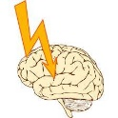
At the moment both the HASU and ASU are at CGH because of Covid-19.
If someone goes to GRH with a stroke, they are seen by the stroke team and sent to CGH for an assessment if they need it.
The stroke team give other health staff in the hospital advice and support.

Our Ideas.
We think we should carry on having the HASU and ASU at CGH
It is easier to give manage and give good care if both units are in the same place.
It would be difficult to have the HASU and ASU at GRH as getting a bed there can be difficult.
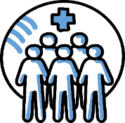
What this means.
People can see the right staff at the right time.
It is easier to cover when staff are sick or away.
People will not have to be transferred between hospitals as often.
Some people will need to travel further.
Thank you for reading about our ideas for our special health services in Gloucestershire.

Please tell us what you think by filling in our survey.

You can tell us what you think online
https://getinvolved.glos.nhs.uk/
You can fill in our survey on paper and get in touch
By email glccg.participation@nhs.net
By phone 0800 0151 548
By Post FREEPOST RRYY-KSGT-AGBR
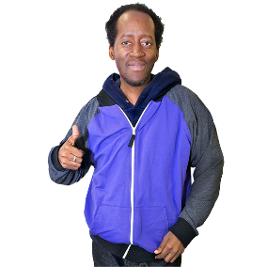
Fit for the Future
Sanger House
5220 Valiant Court
Gloucester Business Park
GL3 4FE
31
July

Please complete your survey and get it back to us by 12 noon on 31 July 2022.

